Assignment 3.2

We have a dataset of sales of different TV sets across different locations.
Records look like:
Samsung|Optima|14|Madhya Pradesh|132401|14200
The fields are arranged like:
Company Name|Product Name|Size in inches|State|Pin Code|Price
There are some invalid records which contain 'NA' in either Company Name or Product Name.
Writing a Map Reduce program to filter out the invalid records. Map only job will fit for this context.
Driver class1
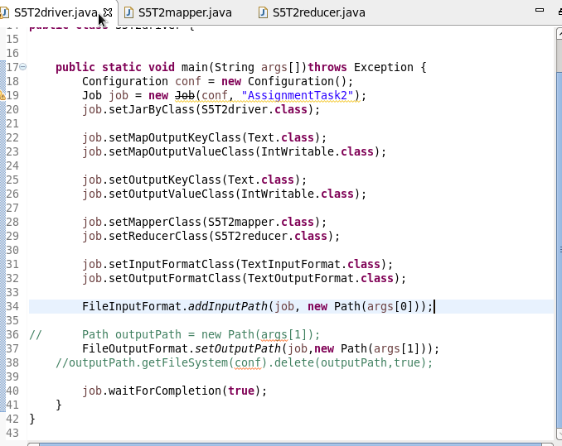
Driver class2
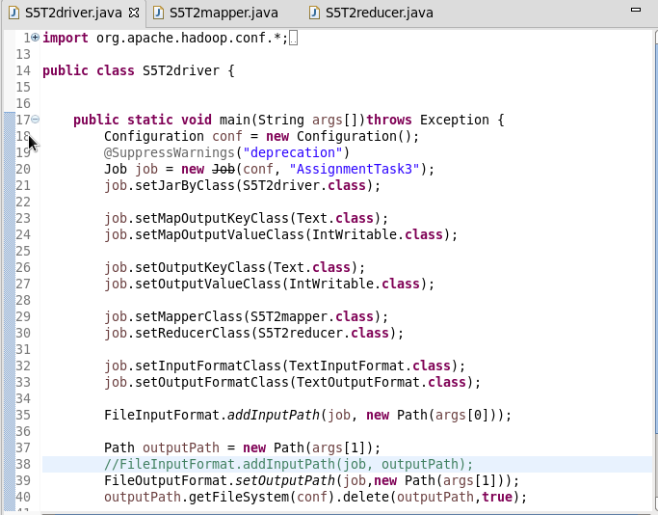

Mapper class1
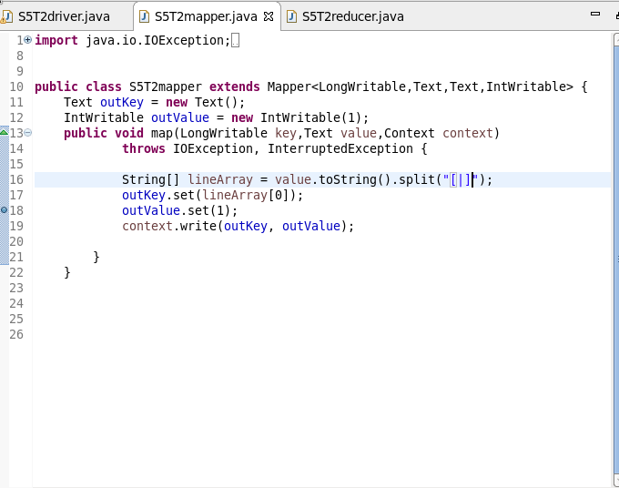

Mapper class2
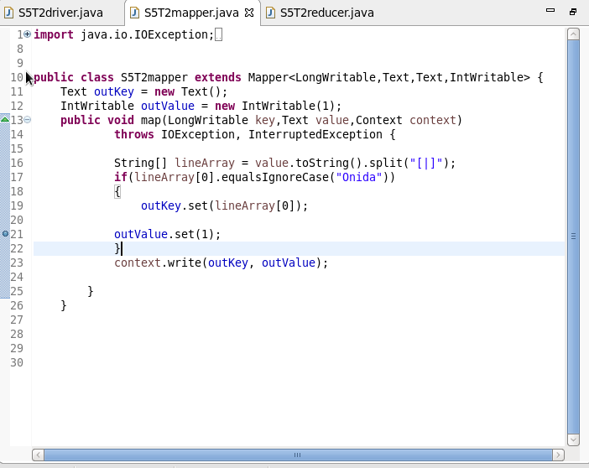

Reducer class1
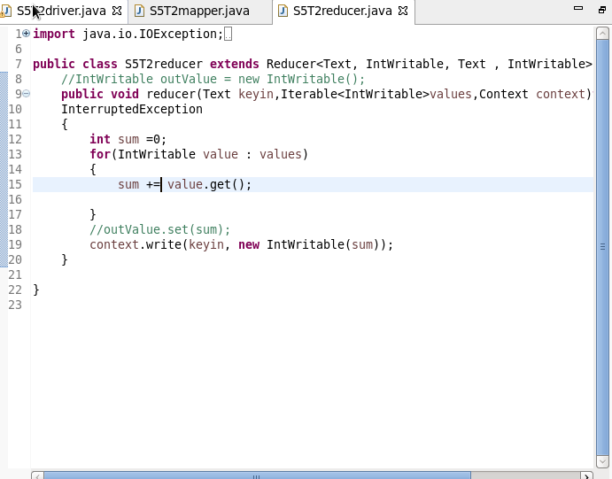
Reducer class2
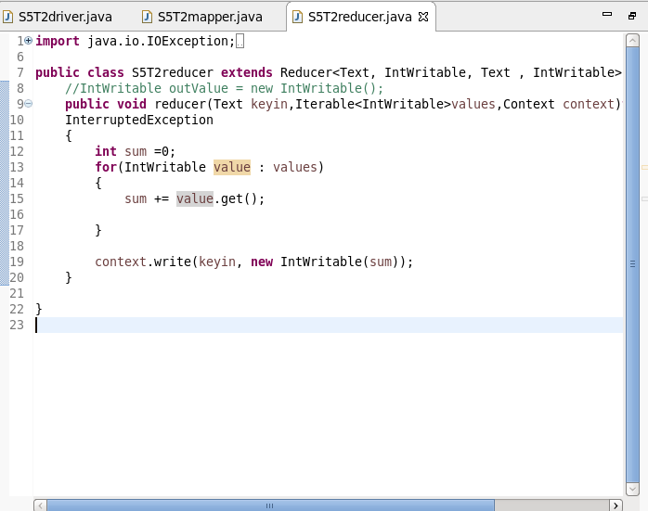

Output 1
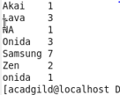

Output 2
